One Forecast, Many FARMS: Why Hyperlocal Weather Advice Can Still Fail Farmers
Dr. Chiranjit Mazumder
Scientist, Division of Agricultural Economics
ICAR-Indian Agricultural Research Institute, New Delhi 110012, India
Corresponding author Email: majumder.chira@gmail.com
Abstract
Hyperlocal weather forecasting is rapidly becoming more precise, timely and accessible to farmers, but greater spatial resolution does not automatically produce better farm decisions. The same rainfall forecast can imply very different risks for neighboring farms because crops, growth stages, soils, drainage, irrigation access, labour availability and recent field operations differ. This article explains why the crucial gap lies between predicting weather and translating uncertain forecasts into feasible, farm-specific actions. Drawing on India's agrometeorological advisory system and recent evidence on forecast verification and farmer response, it highlights observation, model, translation, communication, feasibility and feedback failures that can weaken otherwise useful forecasts. It argues for a shift from forecast delivery to decision-ready services that combine probabilistic information with crop and farm context, conditional recommendations, consequence-based warnings, local intelligence and continuous verification. Hyperlocal forecasting can become a powerful public good when uncertainty is communicated honestly and advice is tailored to the farmer's actual exposure and capacity to act.
Keywords: hyperlocal weather forecast; agrometeorological advisory; farm decision support; forecast uncertainty; climate services; India

The same message, three different risks
At 7:00 a.m., three farmers in the same block receive the same alert: “Moderate rainfall is likely during the next 48 hours. Postpone irrigation and pesticide spraying.” The first farmer has newly transplanted rice in a low-lying clay field. The second grows flowering vegetables on a raised sandy plot. The third has harvested mustard waiting under a temporary sheet. The forecast is identical; the exposure is not. Rain may save irrigation for the rice farmer, leave the vegetable field almost dry, and damage the mustard farmer’s marketable grain.
This is the paradox of hyperlocal weather advice. Forecasts are becoming faster, finer and increasingly supported by artificial intelligence. Yet a forecast attached to a village name or one-kilometre grid is still a description of the atmosphere—not a prescription for a farm. To become advice, it must pass through another layer of reasoning: What is growing? At what stage? In what soil? With what drainage, labour, irrigation and capacity to absorb a wrong decision?

India is entering the age of forecast-led farming
India already operates a vast public agrometeorological system. Under Gramin Krishi Mausam Sewa, the India Meteorological Department (IMD), ICAR institutions, agricultural universities and field units combine weather forecasts with crop information to issue district- and block-level advisories. IMD’s standard procedure calls for five-day quantitative forecasts of rainfall, maximum and minimum temperature, humidity, wind and cloud cover, with advisories issued twice weekly (India Meteorological Department [IMD], 2021).
The system is now being augmented by AI and large-scale digital delivery. During Kharif 2025, a pilot blended NeuralGCM, the European Centre for Medium-Range Weather Forecasts’ AI Forecasting System and 125 years of IMD rainfall data to predict local monsoon onset. Probabilistic messages reached more than 3.88 crore farmers across 13 states in five regional languages. Surveys in Madhya Pradesh and Bihar indicated that 31–52% of respondents changed land preparation, sowing time, crop choice or input decisions (Press Information Bureau [PIB], 2026).
That reach is impressive. It also raises the stakes. A message that changes sowing can influence seed viability, labour expenditure and the entire cropping calendar. The relevant question is therefore no longer only “Can we forecast more locally?” It is “Can we convert uncertainty into safer, farm-specific choices?”

Why hyperlocal can still miss the field
Rainfall is spatially discontinuous. A convective cloud may release intense rain over one cluster of fields and leave another cluster a few kilometres away nearly dry. Hills, coastlines, urban surfaces, tree cover, canals and water bodies further alter local weather. A model can therefore be correct for a grid or block while being wrong at one farm.
The time scale matters as much as the map scale. “Twenty millimetres tomorrow” does not reveal whether rain will fall gently over six hours or arrive as a 30-minute burst. It does not say whether the event begins before a pesticide dries, after harvested grain is covered, or several hours later than expected. For many farm operations, timing within the day matters more than the daily total.
Fine resolution can also create false confidence. Dividing a model output into smaller pixels produces more detail, but it cannot create observations where gauges, radar coverage or maintenance are inadequate. Downscaling is valuable, but the apparent precision of the display may exceed the precision of the underlying evidence.
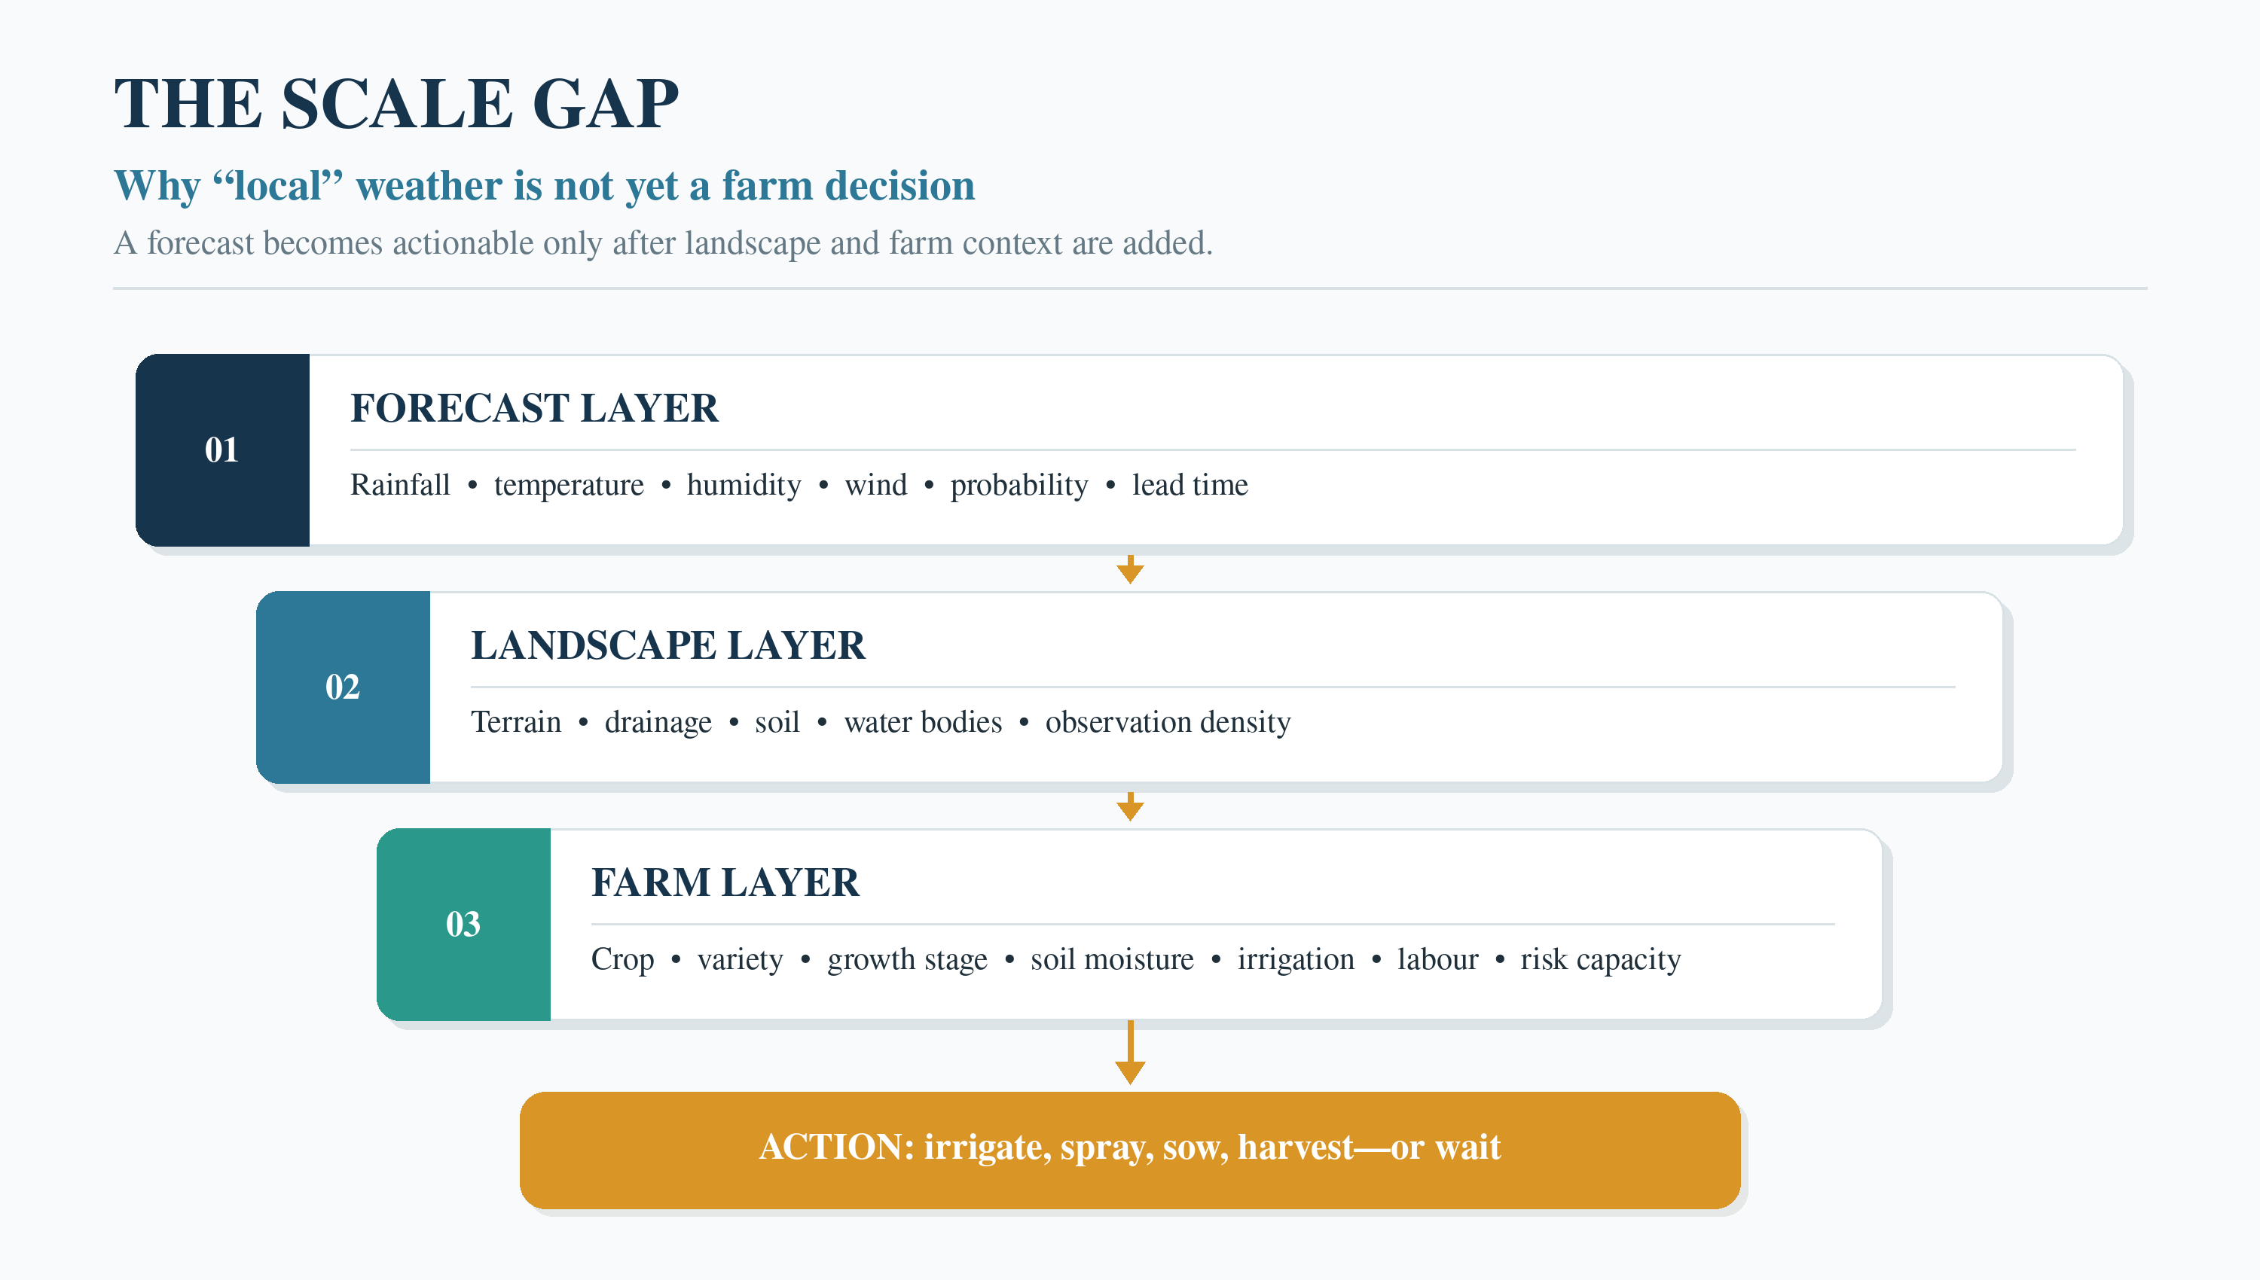
Figure 1. Three information layers between a weather forecast and a defensible farm action. Source: Author’s conceptualisation.

Accuracy is necessary—but economic value is different
Forecast verification asks whether an event was correctly predicted. Farmers ask a different question: did acting on the information improve the result? A forecast can score reasonably well and still have little value if it arrives late, uses unclear language or recommends an action whose cost exceeds the avoided loss. Conversely, a forecast with modest accuracy may be valuable when it triggers a cheap, reversible precaution.
A Karnal district case study illustrates why a local label should not be confused with certainty. For the 2021 southwest monsoon, successful rainfall-forecast percentages across five blocks ranged from 59.4% in Karnal block to 65.3% in Nilokheri. False-alarm ratios ranged from 40% to 48% (Kumar et al., 2024). These results do not represent all Indian forecasts; they show that skill can differ meaningfully even among neighbouring blocks and that a user must understand both missed events and false alarms.
The economic consequences are asymmetric. A false rain alarm may lead a farmer to postpone irrigation, spraying or harvesting. A missed rainfall event may wash away pesticide, waterlog a field or spoil produce. Which error matters more depends on crop stage and the relative costs. “Percentage correct” alone cannot answer that question.
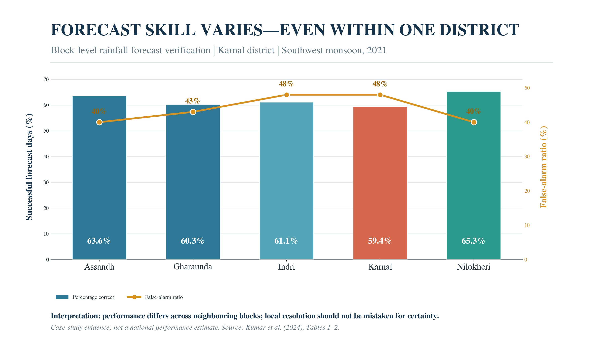
Figure 2. Block-level rainfall-forecast verification in Karnal district, June–September 2021. Data: Kumar et al. (2024), Tables 1–2.

Where the advisory chain breaks
- Observation gap. Sparse or poorly maintained local stations make it difficult to represent and verify small-area rainfall. Satellite and radar products help, but they also have retrieval errors and require local validation.
- Model and lead-time error. The atmosphere is chaotic. Forecast uncertainty generally grows with lead time, while short-lived local storms remain difficult to place precisely.
- Translation error. A technically correct forecast becomes weak advice when crop stage, soil moisture, drainage, pest pressure or recent operations are missing.
- Communication error. “Rain likely” is often heard as “rain will occur.” Probability, expected range, timing and the possibility of change are rarely conveyed together in plain language.
- Feasibility error. Advice may assume that labour, machinery, irrigation, drainage, credit or storage can be rearranged immediately. Many smallholders cannot act on demand.
- Learning failure. If services count messages sent but do not record who understood, acted, benefited or lost, the same weak recommendation can be repeated season after season.
Evidence from 612 farm households in Pakistan reinforces this distinction. Although more than half reported using weather and climate information, the estimated effects on revenue, costs, profits and input use were statistically insignificant. Farmers cited unreliable, unclear information and insufficient use of local languages (Nepal et al., 2024). Distribution is therefore not the same as decision support.

One forecast can rationally produce opposite actions
Farm situation | Main exposure | Rational response | Information still needed
Transplanted rice; low field | Waterlogging after additional rain | Skip irrigation; open drainage | Current ponding, bund height, outlet
Flowering vegetables | Disease and spray wash-off | Use a dry window or suitable formulation | Pest pressure, drying time, rain timing
Harvested grain outdoors | Quality loss from even a short shower | Cover or move produce first | Storage, labour, transport
Dryland seedbed | Germination failure if rain is too little or isolated | Prepare seed; sow only after threshold | Root-zone moisture and follow-up rainfall
Table 1. The same atmospheric forecast can imply different actions because exposure, thresholds and constraints differ.

From forecast delivery to decision service
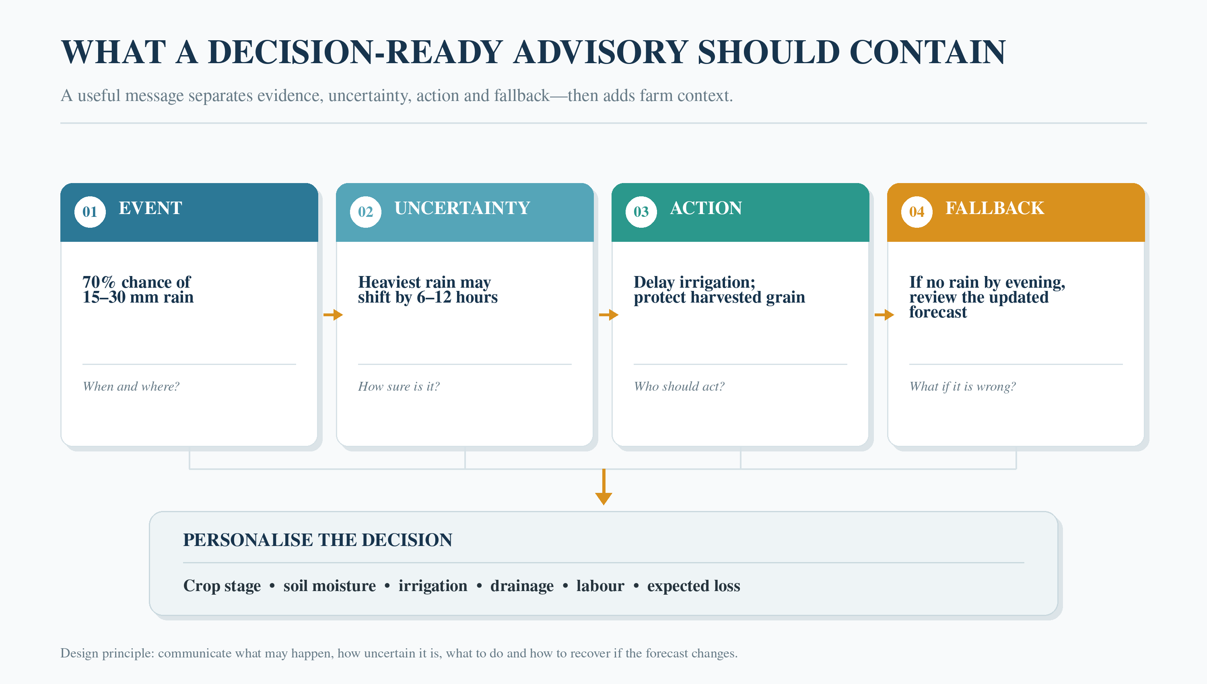
Figure 3. A four-part architecture for decision-ready weather advice. Source: Author’s conceptualisation.
- Personalise the situation, not merely the coordinate. A farmer profile should include crop, variety, sowing date, growth stage, soil type, soil moisture, irrigation, drainage and recent operations. The farmer must be able to correct these fields easily.
- Express uncertainty as a usable choice. Instead of “moderate rain expected,” say: “There is a 70% chance of 15–30 mm, mainly from afternoon to night; the timing may shift by 6–12 hours.” Then connect that uncertainty to low-regret actions.
- Issue conditional recommendations. A short decision tree is safer than one universal command: if soil is already wet, clear drainage; if spraying is essential, use the identified dry window; if grain is harvested, prioritise protection.
- Match warnings to consequences. Sowing, spraying, irrigation, harvesting and livestock protection involve different losses. High-consequence decisions deserve more frequent updates, stronger validation and clear escalation to a human expert.
- Combine AI with local intelligence. Extension workers, Krishi Vigyan Kendras, farmer groups and local observers can supply crop-stage, waterlogging, pest and outcome feedback that atmospheric models cannot infer reliably. WMO similarly stresses farmer participation in co-producing climate services (World Meteorological Organization [WMO], n.d.).
- Verify both weather and advice. IMD procedures already recognise forecast verification. The next step is routine advisory verification: Was the message timely? Was it understood? Was the action feasible? What loss was avoided—or unintentionally created?
- Keep accountable humans in the loop. IMD’s Mausam SANKALP seeks a shift from descriptive weather information toward crop-centric, risk-informed decision support and explicitly positions analytics as an aid to expert judgement (IMD, 2026). That principle should be non-negotiable for costly or irreversible recommendations.

The last kilometer is a reasoning kilometer
Hyperlocal weather services remain a powerful public good. They can save irrigation, reduce wasted inputs, protect harvests and provide precious preparation time. The lesson is not that farmers should distrust forecasts whenever one storm is missed. Forecasts are probabilistic, and honest uncertainty can still produce better decisions.
The danger is precision theatre: a village label, sharp map or decimal value that appears more certain than the observations, model and farm context justify. Better technology must therefore be matched by better communication, local verification, economic reasoning and feedback from the people who act on the message.
The success of agricultural weather services should finally be judged by more than reach. The decisive test is whether a particular farmer received enough context, enough warning and a feasible alternative to act wisely. One forecast may serve many farms. One instruction rarely should.

References
India Meteorological Department. (2021). Standard operating procedure for agromet advisory services. Ministry of Earth Sciences. https://mausam.imd.gov.in/imd_latest/contents/pdf/gkms_sop.pdf
India Meteorological Department. (2026). Mausam SANKALP: Systematic Agromet aNalytics, Knowledge and Advisory enabLing Platform. Ministry of Earth Sciences. https://mausam.imd.gov.in/imd_latest/contents/agromet/kalp/sankalp.pdf
Kumar, A., Kumar, Y., Bhardwaj, M., & Giri, R. K. (2024). Evaluation of INSAT-3DR Hydro-Estimator product for monsoon season rainfall at block-level and its utility in forecast verification: A case study in Karnal district, India. Mausam, 75(3), 759–768. https://doi.org/10.54302/mausam.v75i3.6216
Nepal, M., Ashfaq, M., Sharma, B. R., Shrestha, M. S., Khadgi, V. R., & Bruno Soares, M. (2024). Impact of weather and climate advisories on agricultural outcomes in Pakistan. Scientific Reports, 14, Article 1036. https://doi.org/10.1038/s41598-023-51066-4
Press Information Bureau. (2026, February 14). Artificial intelligence transforming Indian agriculture. Government of India. https://www.pib.gov.in/PressReleasePage.aspx?PRID=2227914
World Meteorological Organization. (n.d.). WMO technical advisory under AIM for Scale. Retrieved August 5, 2026, from https://wmo.int/activities/projects/project-portfolio/wmo-technical-advisory-under-aim-scale

